# Introduction:

Calgary City is situated in the western province of Canada in Alberta. According to the 2019 statistics the city had a population of 1.286 million, making it Alberta’s most populated city (1). Although the winters in Calgary city can get a bit cold at times, there are plenty of perks about living in Calgary city. According to Economist’s Global Livability Ranking, Calgary city has been named one of the top five most livable cities for the past five years. The ranking assesses livability based on stability, healthcare, culture, environment, education and infrastructure (2).

Asides from the livability ranking, according to the 2018 census for metropolitan area, Calgary have the highest concentration of head offices in Canada and is home to 115 or approximately 1 in 7 of Canada’s 800 largest corporate headquarters (Ly, 2018). With the numerous head offices and corporate offices situated in Calgary, the number of coffee shops located in Calgary is also abundant. This report will focus on analyzing the coffee venues in Calgary city to offer an assessment on how the location and surrounding venues might affect the overall performance of the coffee shops. By exploring the neighborhood venues of the coffee shops, this report will provide insight to business owners on potentially where to open a new coffee shop in Calgary.

## Data Sources and Preparation

Based on the problem definition, the different factors to be considered in the analysis includes:

* Calgary neighbourhood and demographic information
* Number of different coffee shop venues in Calgary neighbourhoods
* The types of venues surrounding the coffee shops
* Coffee shop ratings, likes, photos, tips and price

The data sources and preparation methods are listed below:

#### Data Sources

* Calgary Neighbourhood and Census Dataset: <https://en.wikipedia.org/wiki/List_of_neighbourhoods_in_Calgary#cite_note-opendatacommunities-11>

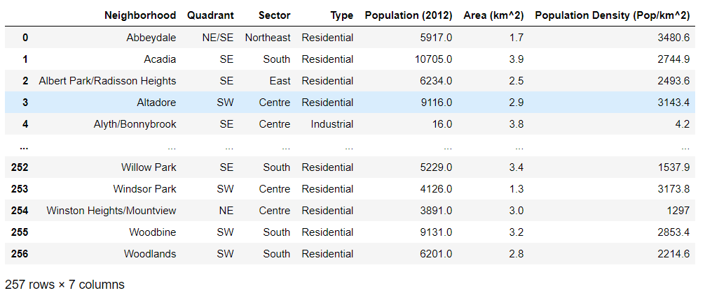

* Calgary Neighborhood Geojson File: <https://raw.githubusercontent.com/blackmad/neighborhoods/master/calgary.geojson>

#### Data Preparation:

* *Geopy*—is used to scrape the Calgary Neighbourhood and Census Dataset to generate latitude and longitude information for further analysis
* *Foursquare API*—is used to explore the Calgary neighbourhoods to generate the list of venues
* *Foursquare API*—is also used to obtain detailed information for each venue including ratings, likes, photos, tips and price

# Bibliography

1. Calgary. *Wikipedia.* [Online] [Cited: 11 25, 2020.] https://en.wikipedia.org/wiki/Calgary.

2. Global Liveability Ranking. *Wikipedia.* [Online] [Cited: 11 26, 2020.] https://en.wikipedia.org/wiki/Global_Liveability_Ranking.

3. Ly, P. U. B. L. I. S. H. E. D. J. U. (2018). Fact Sheet : Calgary Head Offices, 1–5.